Mini Project Report On
“ Library Management System ”

Submitted by:
Premraj Gopichand Goykar (RBT25CB036)
Harshadeep Praful Thul (RBT25CB022)

Under the guidance of
Prof. Rutuja S. Bachhav
Course: DBMS

Academic Year: 2026–27 (Semester III)

Table of Contents

1. Abstract
2. Introduction
3. Literature Survey / Existing System
4. Proposed System
5. Methodology / Implementation
6. Results and Discussion
7. Conclusion and Future Scope
8. References

Course Outcomes:
CO1: Design a database schema and 2 –tier application for a given problem statement.
CO2: Design SQL DDL/DML quries to create, secure, populate, maintain, and query a database using integrity constraint, stored function/procedure, cursor, trigger using PL/SQL block.
CO2: Design NO SQL query using mongoDB platform.

PO Mapped
PO1: Engineering Knowledge: Apply knowledge of mathematics, natural science, computing,
engineering fundamentals and an engineering specialization as specified in WK1 to WK4 respectively to develop to the solution of complex engineering problems
PO2: Problem Analysis: Identify, formulate, review research literature and analyze complex engineering problems reaching substantiated conclusions with consideration for sustainable development.
PO3: Design/Development of Solutions: Design creative solutions for complex engineering problems and design/develop systems/components/processes to meet identified needs with consideration for the public health and safety, whole-life cost, net zero carbon, culture, society and environment as required.
PO4: Conduct Investigations of Complex Problems: Conduct investigations of complex engineering problems using research-based knowledge including design of experiments, modeling, analysis & interpretation of data to provide valid conclusions.
PO5: Engineering Tool Usage: Create, select and apply appropriate techniques, resources and modern engineering &amp; IT tools, including prediction and modeling recognizing their limitations to solve complex engineering problems.
PO8: Individual and Collaborative Team work: Function effectively as an individual, and as a member or leader in diverse/multi-disciplinary teams.
PO9: Communication: Communicate effectively and inclusively within the engineering community and society at large, such as being able to comprehend and write effective reports and design documentation, make effective presentations considering cultural, language, and learning differences
PO10: Project Management and Finance: Apply knowledge and understanding of engineering management principles and economic decision-making and apply these to

one’s own work, as a member and leader in a team, and to manage projects and in multidisciplinary environments.
PO11: Life-Long Learning: Recognize the need for, and have the preparation and ability for i) independent and life-long learning ii) adaptability to new and emerging technologies and iii) critical thinking in the broadest context of technological change.
PSO Mapped
PSO 1: Integrated Technical Proficiency: Ability to analyze, designs, and implement comprehensive software and business systems using modern tools and techniques, ensuring intelligent, efficient, and sustainable solutions.
PSO 2: Data-Driven Decision Making: Ability to apply mathematical and data analytics methods including algorithms, statisticalmodels, and data structures to solve complex computational and business problems and support innovation.
PSO 3: Interdisciplinary Collaboration &amp; Professionalism: Ability to effectively collaborate in multidisciplinary teams, integrating technical and business perspectives, and to communicate and manage projects with professional ethics and societal responsibility.
SDG Goals Mapped
SDG 4: Quality Education: Develops students’ practical skills in database design, SQL, PL/SQL, NoSQL, and modern database technologies.
SDG 8: Decent Work and Economic Growth: Enhances students’ technical and problem-solving skills required for employment and professional development in the IT industry.
SDG 9: Industry, Innovation and Infrastructure: Promotes the development of technology-based database solutions using SQL, PL/SQL, and MongoDB.
SDG 12: Responsible Consumption and Production: Encourages efficient data management, storage, and utilization of computing resources.

- Abstract
The Library Management System is a two-tier database application built to run the day-to-day work of a college library. A web interface (HTML, CSS, JavaScript) is used by the librarian, a Flask (Python) back end validates every request and applies the library rules, and all data is stored in a MySQL relational database named LibraryDB.
The database has six tables: Member, Book, Issue, Fine, Librarian and Audit_Log, connected by primary keys, foreign keys and UNIQUE and CHECK constraints, together with a view for overdue books and an optional stored procedure and trigger. The application supports issuing, returning and renewing books, automatic due dates and fines, search, editing, reports and CSV export.
To make the system reliable for daily use, the project adds librarian login with hashed passwords and roles, protection against forged requests, every multi-table change inside a single database transaction, an atomic stock update, an activity log, error handling and logging, backups, automated tests (27 passing), Docker deployment and continuous integration on GitHub.
Keywords: DBMS, MySQL, SQL, Flask, REST API, Transactions, Authentication, Audit Log, Library Management, Primary Key, Foreign Key

- Introduction
Libraries maintain a large amount of information related to books, members, issue and return transactions, and fines. In a traditional manual system, this information is kept in registers or separate records. As the number of books and members increases, managing such records becomes time-consuming and error-prone.
A Database Management System stores this information in an organized way and lets several operations work on the same data safely. This project turns the database into a complete working application: the librarian signs in, searches the catalogue, issues and returns books, and sees overdue books and fines on a dashboard, while the database guarantees that the records stay consistent.
The database contains six tables: Member, Book, Issue, Fine, Librarian and Audit_Log. Member and Book hold the library’s people and stock, Issue records every loan, Fine stores late-return fines, Librarian holds staff accounts, and Audit_Log keeps a history of who did what.
The project demonstrates DBMS concepts such as table design, keys and constraints, JOIN queries, aggregate queries, views, indexes, transactions (commit and rollback), stored procedures and triggers, and the way an application connects to a database (a 2-tier application).
Objectives
- To maintain member and book information, including the number of available copies.
- To track issue, return and renewal of books with due dates.
- To calculate and store fines automatically.
- To protect the data with login, roles, constraints and transactions.
- To provide search, reports, CSV export and an activity log for daily work.
- To make the system easy to install, back up, test and deploy (Docker, GitHub).
- To demonstrate practical DBMS and SQL concepts.

- Literature Survey / Existing System
Traditional library management uses manual registers, paper records or basic spreadsheets. These methods work for a small collection but become difficult as the number of books and members grows. Searching for a record means turning pages, fines are calculated by hand, and there is no reliable way to know how many copies of a book are on the shelf.
Spreadsheets improve searching but cannot enforce relationships between records, cannot stop an invalid entry, do not keep a history of changes, and are unsafe when several people edit the same file. Commercial library software solves these problems but is expensive and often more complex than a small college library needs. Open-source stacks such as Flask and MySQL provide a low-cost alternative.
Limitations of the Existing System
- Time-consuming: Searching and updating records requires more time.
- Data redundancy: The same information may be recorded multiple times.
- Human errors: Manual entry and manual fine calculation produce incorrect or missing records.
- No integrity checks: A book can be issued even when no copies are left.
- No security or history: Anyone can change a record and there is no log of who changed it.
- Difficult tracking: Overdue books and unpaid fines are hard to find.
- No backup: Records can be lost if the register or file is damaged.
A relational database with a connected, secured application solves these problems by storing data in structured tables, enforcing rules automatically, recording every action and allowing regular backups.

- Proposed System
The proposed system is a two-tier web application. The librarian works in a web browser (front end). The browser sends JSON requests to a Flask REST API (back end), which checks the login, validates the input, applies the library rules and runs SQL on the MySQL database. Operations that change more than one table run inside one transaction, so the data never remains half-updated.
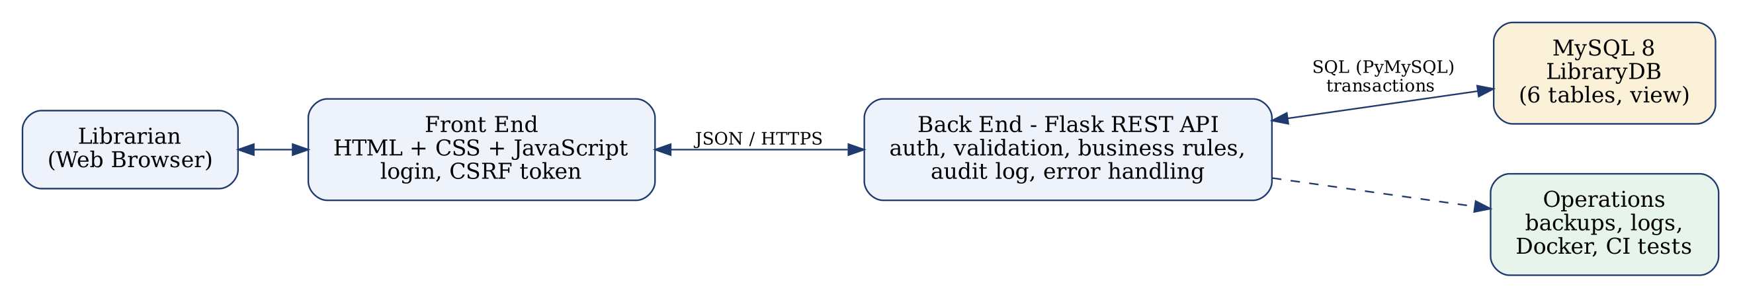
Fig. 1: System architecture
The system consists of six tables:
1. Member Table
Stores information about library members.
Attributes:
- Member_ID — Primary Key (auto-increment)
- Name — NOT NULL
- Department
- Phone — UNIQUE (10 digits)
- Joined_On — registration date

2. Book Table
Stores the books and the number of copies available.
Attributes:
- Book_ID — Primary Key (auto-increment)
- Title, Author — NOT NULL
- Category
- Quantity — copies on the shelf, CHECK (Quantity >= 0), index on Title

3. Issue Table
Records every issue, return and renewal.
Attributes:
- Issue_ID — Primary Key
- Member_ID — Foreign Key (Member)
- Book_ID — Foreign Key (Book)
- Issue_Date, Due_Date (issue date + 14 days)
- Return_Date — NULL while the book is still issued
- Renewed — 0 or 1 (one renewal allowed)

4. Fine Table
Stores the fine for a late return.
Attributes:
- Fine_ID — Primary Key
- Issue_ID — Foreign Key (Issue), UNIQUE
- Amount — days late × ₹2, CHECK (Amount >= 0)
- Paid — 0 = unpaid, 1 = paid

5. Librarian Table
Stores staff accounts for signing in.
Attributes:
- Librarian_ID — Primary Key
- Username — UNIQUE
- Full_Name
- Password_Hash — salted PBKDF2-SHA256 hash (the password is never stored)
- Role — admin or librarian

6. Audit_Log Table
Keeps a history of important actions (sign-in, issue, return, renew, add, edit, delete, fine payment).
Attributes:
- Log_ID — Primary Key
- Username, Action, Detail
- Logged_At — time of the action

Library Rules Implemented
- A book can be issued only if a copy is available.
- A member can hold at most 3 books and cannot hold two copies of the same title.
- A member with an unpaid fine cannot borrow another book.
- Loan period is 14 days; a book can be renewed once, and only if it is not overdue.
- Fine is ₹2 for every day after the due date.
- A book or member that has issue history cannot be deleted.
- Only an administrator can delete records or view the activity log.

Advantages of the Proposed System
- Organized storage and instant search of all records.
- Automatic due dates, renewals and fines.
- Data consistency through constraints and transactions.
- Secure access with login, roles and an activity log.
- Reports and CSV export for the library office.
- Free, open-source tools and simple deployment with Docker.

- Methodology / Implementation
The project follows a relational database approach with a layered application. The database was designed first (tables, keys and constraints), then the back end that applies the rules, then the web interface, and finally tests and deployment files. The complete source code is organized as a GitHub-ready project.
1. Technology Stack
Layer | Technology | Purpose
Front end | HTML, CSS, JavaScript | Login, dashboard, forms, tables, search and reports
Back end | Python 3, Flask, Gunicorn | REST API, validation, business rules, security
Database | MySQL 8, MySQL Workbench | Storage, relationships, constraints, view, procedure, trigger
Connector | PyMySQL | Runs SQL from Flask on MySQL
Testing | Python unittest | 27 automated tests
Deployment | Docker Compose, GitHub Actions | One-command start and automatic test runs

2. Database Creation and Table Design
The database LibraryDB is created by running schema/mysql.sql (or python manage.py init-db). Each table has a primary key; foreign keys connect Issue to Member and Book and Fine to Issue.
CREATE TABLE Book (
Book_ID INT AUTO_INCREMENT PRIMARY KEY,
Title VARCHAR(120) NOT NULL,
Author VARCHAR(80) NOT NULL,
Category VARCHAR(40),
Quantity INT NOT NULL DEFAULT 0,
CONSTRAINT chk_book_qty CHECK (Quantity >= 0),
INDEX idx_book_title (Title)
) ENGINE=InnoDB;

CREATE TABLE Issue (
Issue_ID INT AUTO_INCREMENT PRIMARY KEY,
Member_ID INT NOT NULL,
Book_ID INT NOT NULL,
Issue_Date DATE NOT NULL,
Due_Date DATE NOT NULL,
Return_Date DATE NULL,
Renewed TINYINT(1) NOT NULL DEFAULT 0,
CONSTRAINT fk_issue_member FOREIGN KEY (Member_ID) REFERENCES Member(Member_ID),
CONSTRAINT fk_issue_book FOREIGN KEY (Book_ID) REFERENCES Book(Book_ID)
) ENGINE=InnoDB;
The other four tables are created in the same way; the full script is in schema/mysql.sql.

3. ER Diagram
The relationships are shown in the ER (Entity-Relationship) Diagram. One member can have many issue records, one book can appear in many issue records, and one issue record can have at most one fine. Librarian and Audit_Log support security and history.
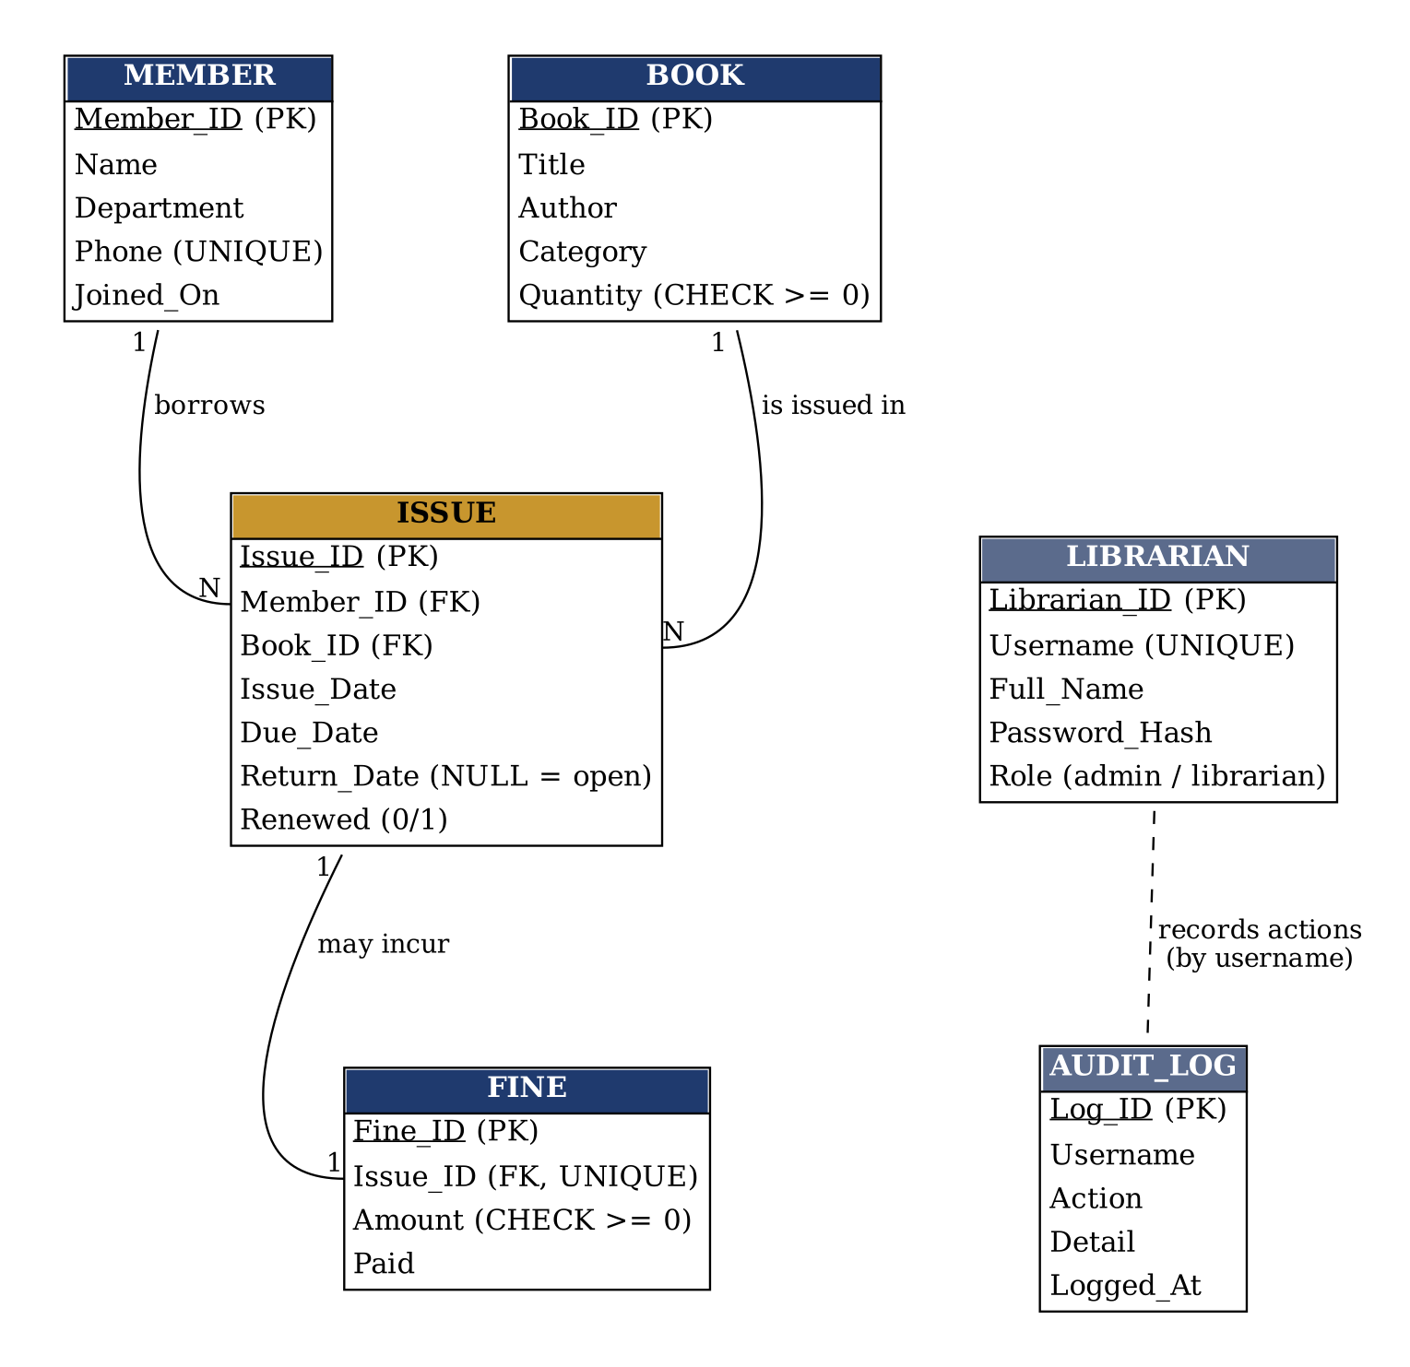
Fig. 2: ER diagram of LibraryDB
4. Back End (Flask REST API)
Each endpoint checks the login, validates the input, runs parameterised SQL (which prevents SQL injection) and returns JSON.
Endpoint | Method | Function
/api/login, /api/logout, /api/password | POST | Sign in, sign out, change password
/api/books, /api/members | GET, POST, PUT, DELETE | List with search and pages, add, edit, delete
/api/issue, /api/return/<id>, /api/renew/<id> | POST | Issue, return (with fine), renew
/api/issues, /api/fines | GET | Issue records (JOIN), fines
/api/fines/<id>/pay | POST | Mark a fine as paid
/api/stats, /api/reports/summary | GET | Dashboard and report data
/api/export/<name>.csv | GET | CSV export
/api/audit, /api/librarians | GET, POST | Activity log, staff accounts (admin)
/health | GET | Database health check

5. Transactions and Reliability
Issuing a book changes the Issue and Book tables and the Audit_Log, so all statements run in one transaction; any failed rule or error rolls everything back. The stock reduction is a single atomic statement, so two librarians cannot issue the last copy at the same time.
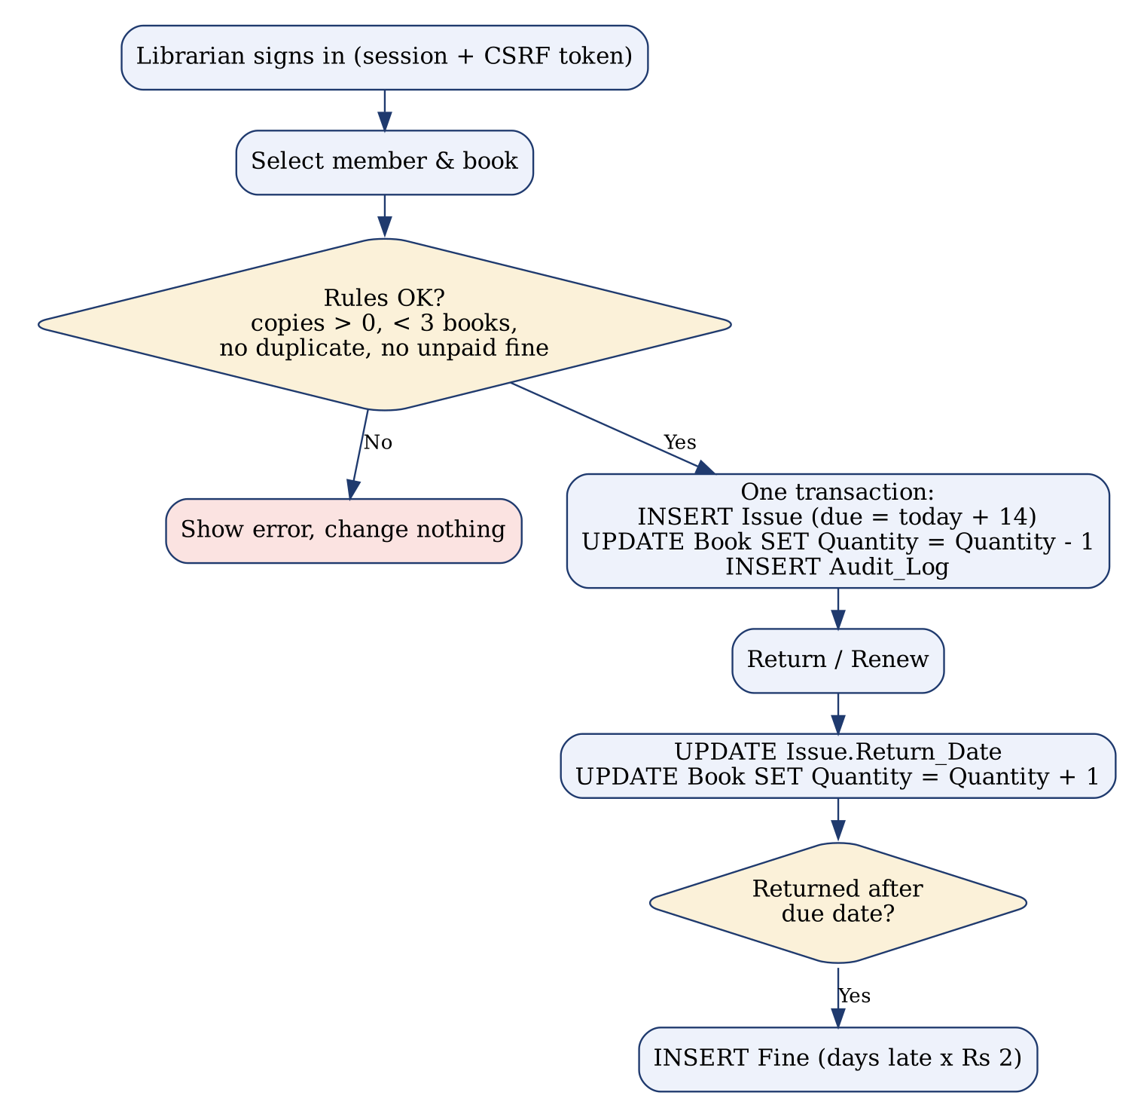
Fig. 3: Flow of issuing, returning and renewing a book
-- inside one transaction
INSERT INTO Issue(Member_ID, Book_ID, Issue_Date, Due_Date) VALUES (%s, %s, %s, %s);
UPDATE Book SET Quantity = Quantity - 1
WHERE Book_ID = %s AND Quantity > 0; -- atomic stock check
INSERT INTO Audit_Log(Username, Action, Detail) VALUES (%s, %s, %s);

6. Security
Risk | Protection used
Unauthorised access | Login with session cookie (HttpOnly, SameSite); every API needs sign-in
Password theft | Passwords stored as salted PBKDF2-SHA256 hashes
Guessing passwords | Lock-out after 5 failed attempts in 15 minutes
Forged requests (CSRF) | Per-session token required on every change
SQL injection | Parameterised queries only
Misuse by staff | Roles: only admin can delete or read the activity log
Spreadsheet formula injection | CSV export neutralises cells starting with = + - @

7. Front End
The front end is a single-page web interface with seven screens: Sign in, Dashboard, Books, Members, Issue / Return, Fines and Reports. It calls the API with JavaScript, shows live search with paging, highlights overdue books, opens an edit dialog for books and members, and displays the success or error message returned by the back end.
8. Additional MySQL Objects
A view vw_overdue lists overdue books, a stored procedure sp_member_history(member_id) returns a member’s borrowing history, and a trigger blocks negative stock.
CREATE OR REPLACE VIEW vw_overdue AS
SELECT i.Issue_ID, m.Name AS Member, b.Title, i.Due_Date,
DATEDIFF(CURDATE(), i.Due_Date) AS Days_Late
FROM Issue i JOIN Member m ON m.Member_ID = i.Member_ID
JOIN Book b ON b.Book_ID = i.Book_ID
WHERE i.Return_Date IS NULL AND i.Due_Date < CURDATE();

9. Operations: Backup, Logging, Docker and GitHub
- python manage.py backup creates a dated backup (mysqldump for MySQL) and keeps the latest 14.
- Application errors and failed logins are written to a rotating log file (logs/app.log).
- docker compose up --build starts MySQL and the application together.
- A GitHub Actions workflow runs all tests on every push.
- README.md explains installation, daily commands and the project layout.

- Results and Discussion
The system was implemented as a complete working application and tested with sample data (10 books, 8 members and 9 issue records, including overdue loans and fines). All 27 automated tests passed. The screenshots below were taken from the running application.
Note: the application screenshots and query outputs were produced with the built-in demo mode of the application (SQLite) that uses the same tables and code as the MySQL version.
1. Database Tables and Sample Data
The following command lists the tables of the database:
SHOW TABLES;

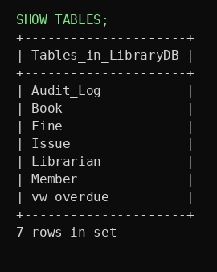
Fig. 4: Tables of LibraryDB
The Member and Book tables after loading the sample data:
SELECT Member_ID, Name, Department, Phone FROM Member;

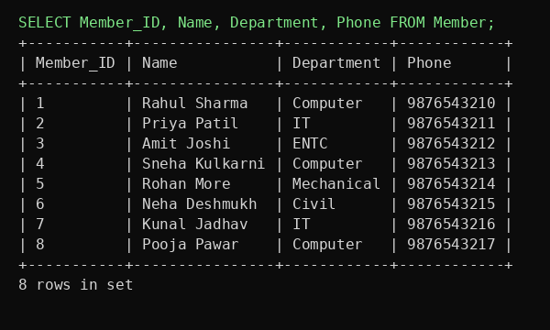
Fig. 5: Member table
SELECT Book_ID, Title, Author, Category, Quantity
FROM Book
WHERE Quantity > 0;

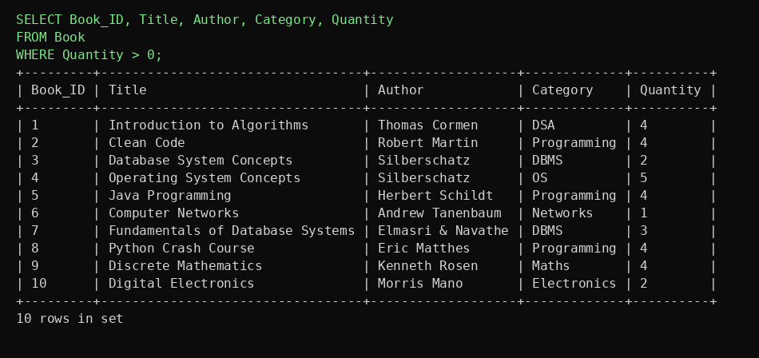
Fig. 6: Books with available copies (WHERE query)
2. JOIN, View and Aggregate Queries
Issue records are produced by joining four tables:
SELECT i.Issue_ID, m.Name, b.Title, i.Issue_Date, i.Due_Date,
i.Return_Date, COALESCE(f.Amount,0) AS Fine
FROM Issue i
JOIN Member m ON m.Member_ID = i.Member_ID
JOIN Book b ON b.Book_ID = i.Book_ID
LEFT JOIN Fine f ON f.Issue_ID = i.Issue_ID;

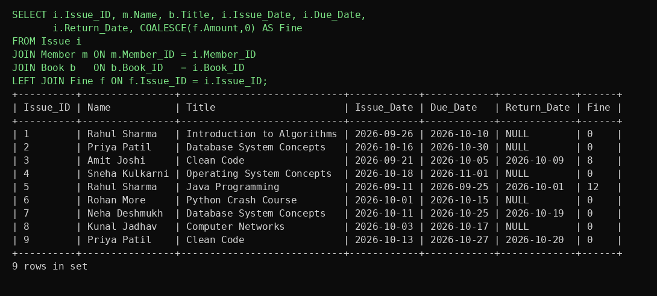
Fig. 7: JOIN of Issue, Member, Book and Fine
Overdue books (the same query as the view vw_overdue):
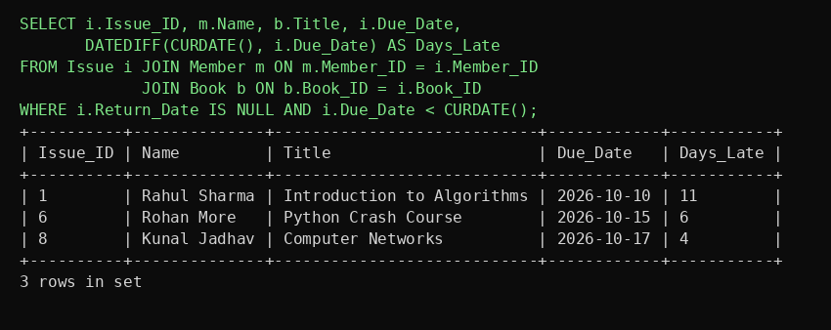
Fig. 8: Overdue books
Most borrowed books and total unpaid fines (aggregate queries):
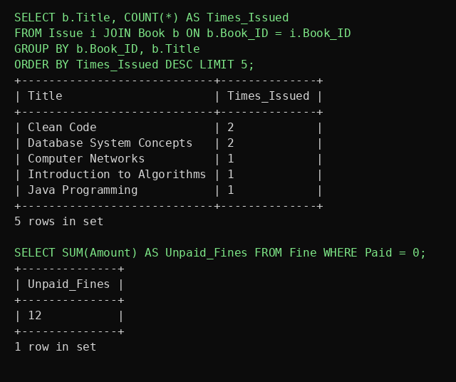
Fig. 9: GROUP BY and SUM queries
3. Application Screenshots
Sign in. The application is protected by a login page. A wrong password shows an error and repeated failures lock the account for a while.
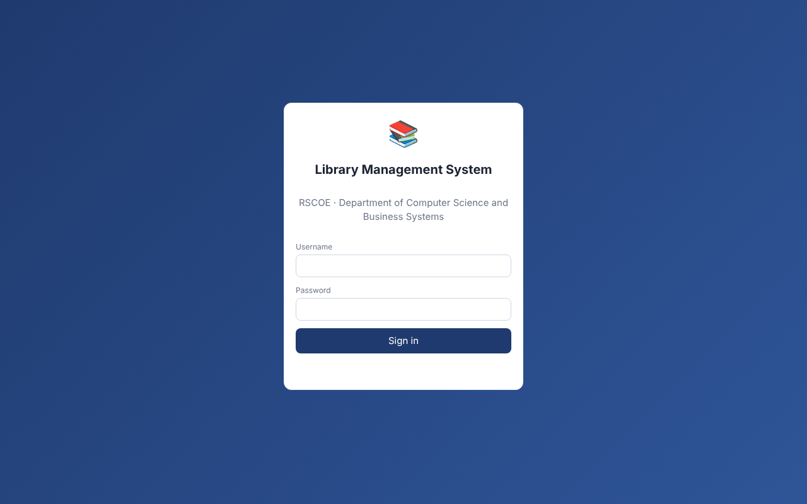
Fig. 10: Login page
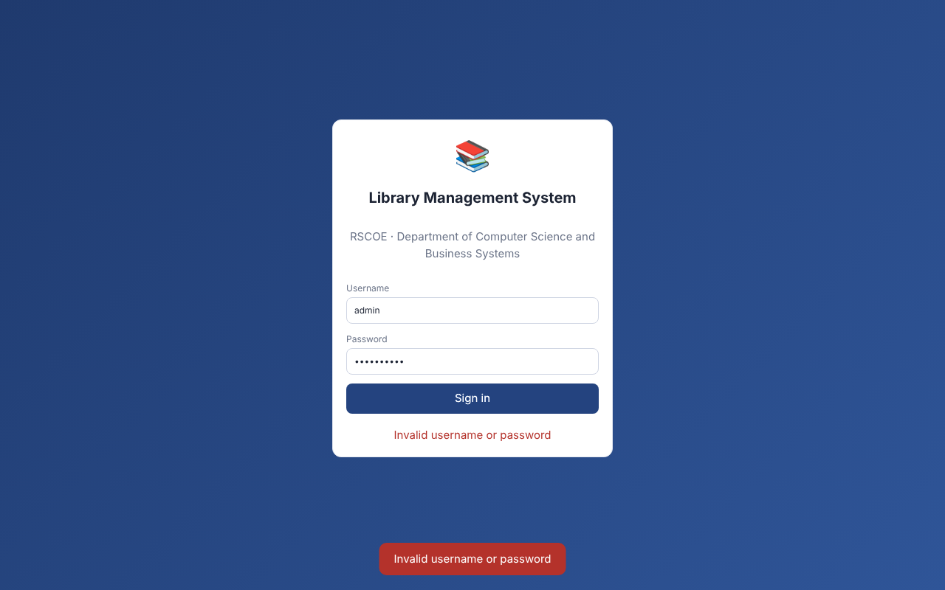
Fig. 11: Failed login
Dashboard. Shows titles, copies on the shelf, members, issued and overdue books, unpaid fines and the list of books currently issued.
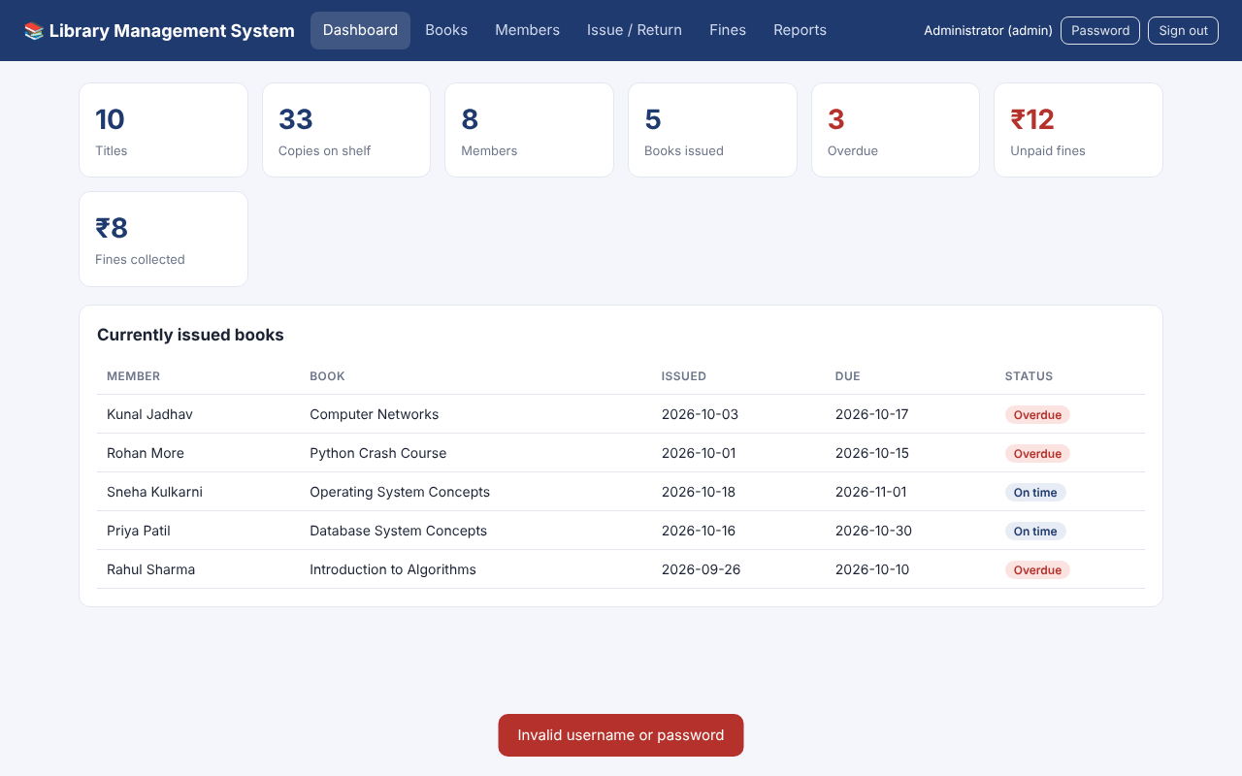
Fig. 12: Dashboard
Books. A book is added with the form and appears in the list at once; the search box filters by title, author or category; the Edit button opens a dialog.
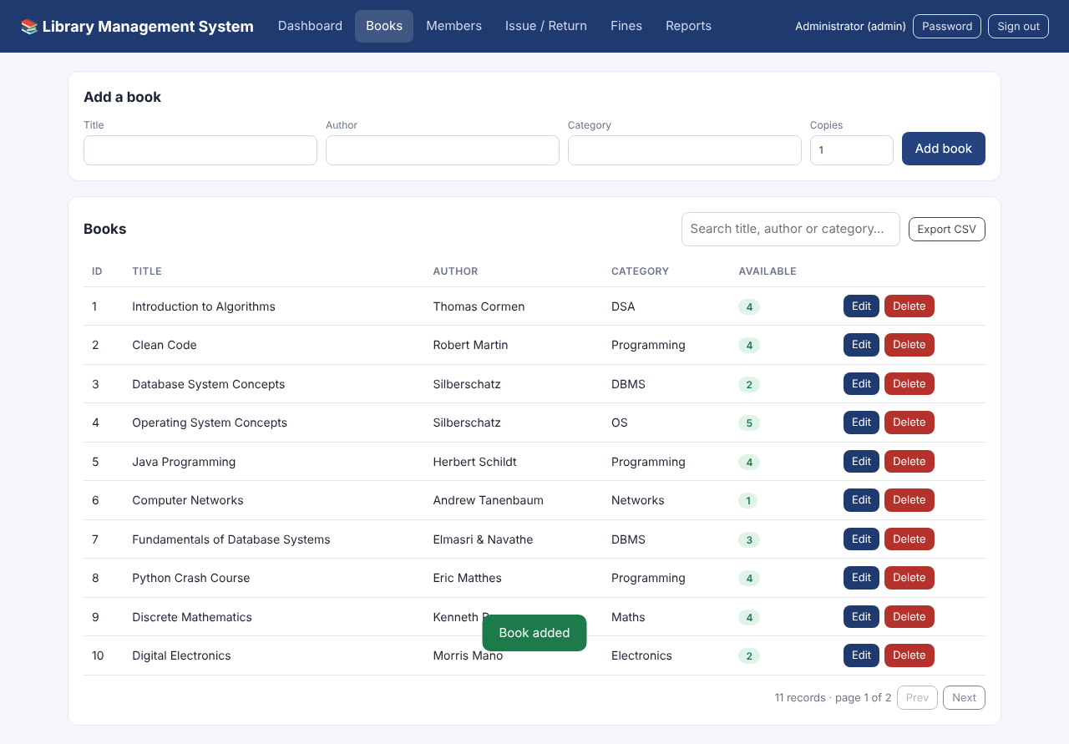
Fig. 13: Adding a book
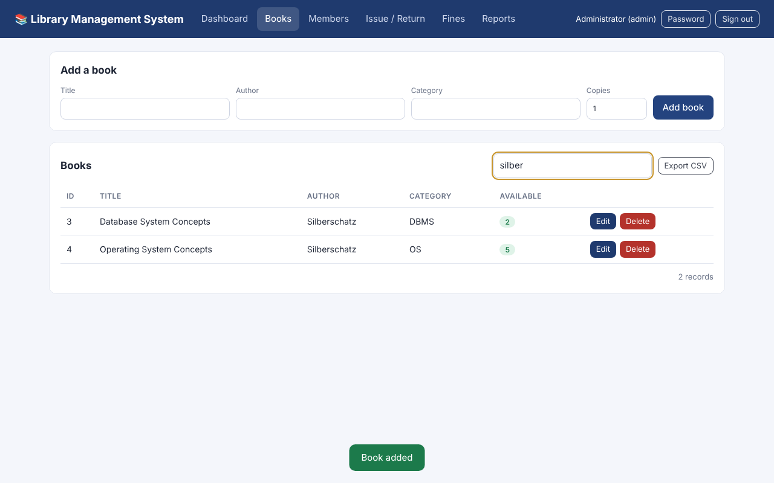
Fig. 14: Searching books
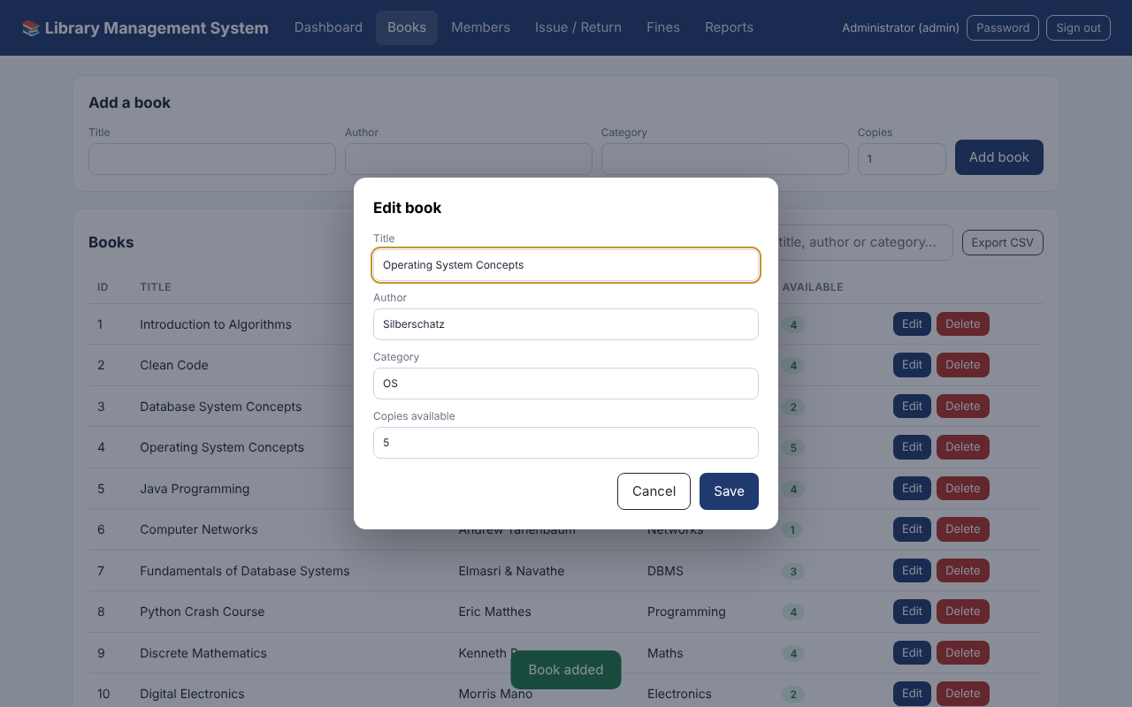
Fig. 15: Editing a book
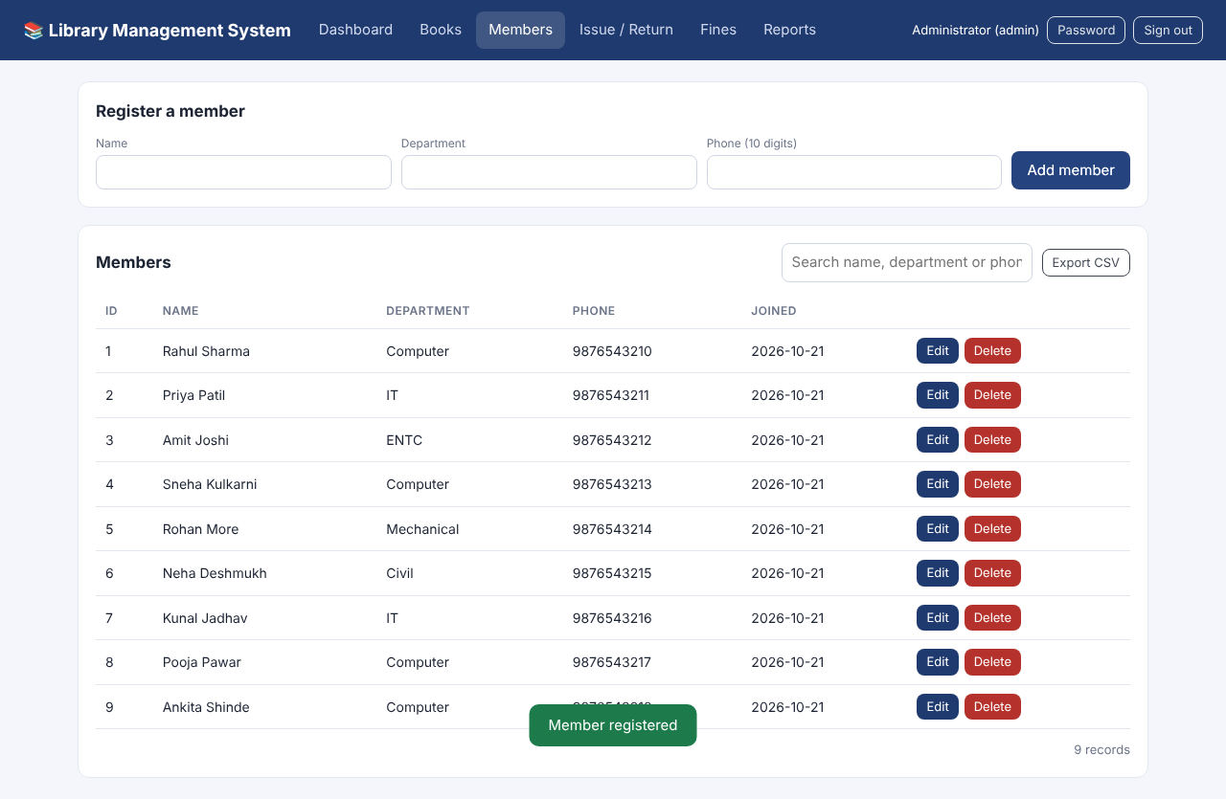
Fig. 16: Members screen with a new member registered
Issue and return. A book is issued with the form, the due date is set automatically, and the stock is reduced. A member with an unpaid fine is blocked.
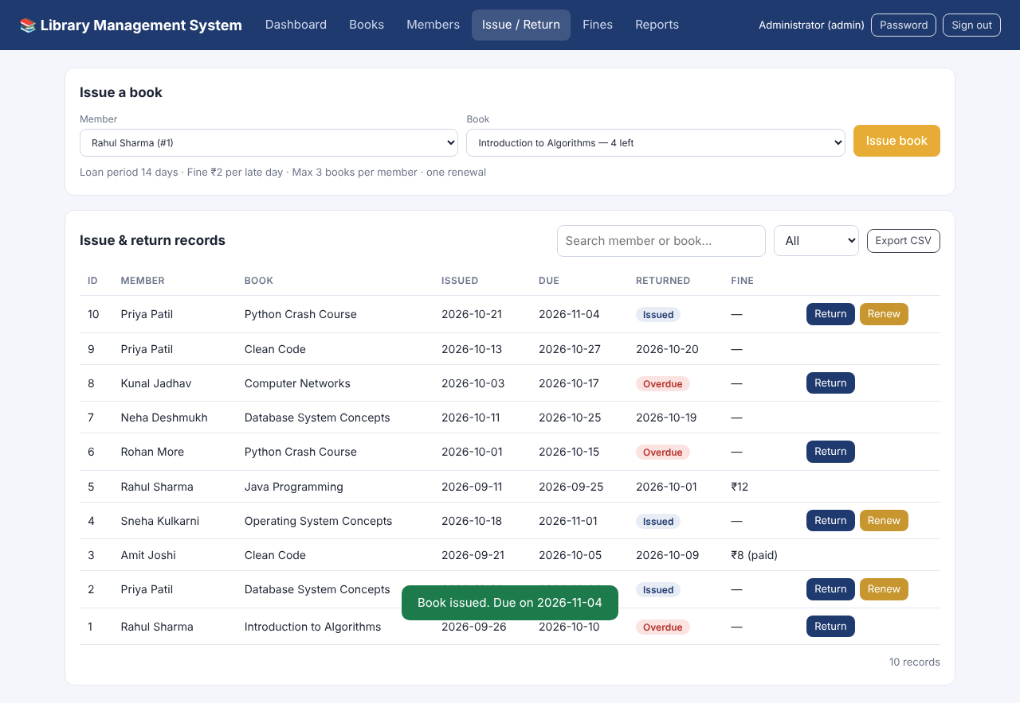
Fig. 17: Book issued (due date shown)
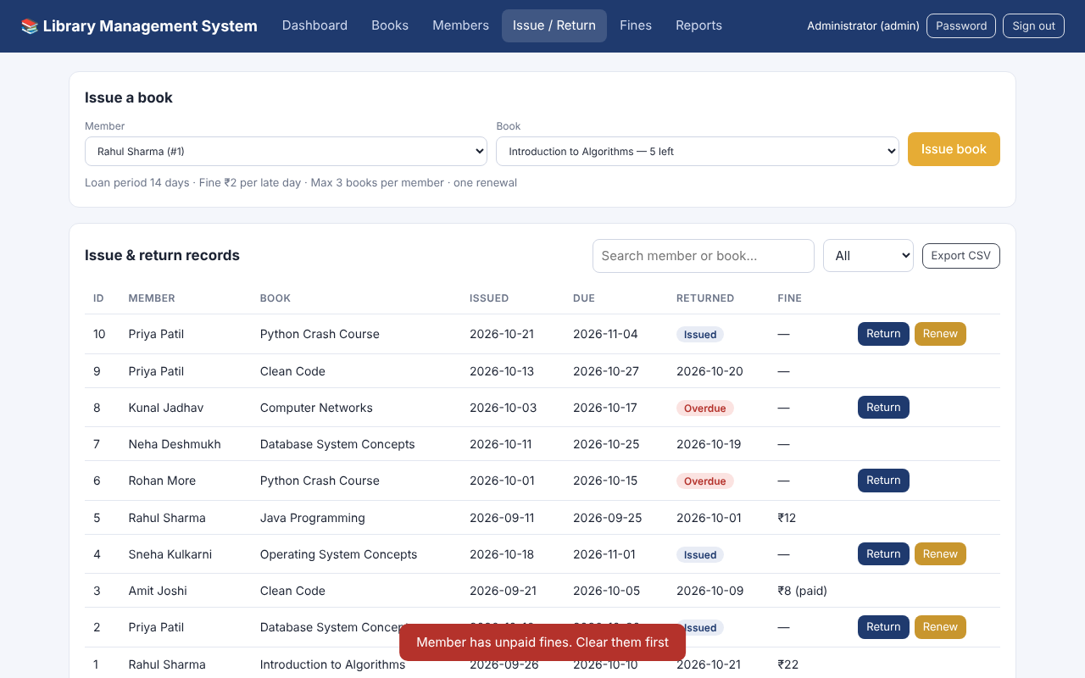
Fig. 18: Issue blocked: unpaid fine
Renewal and return. A book can be renewed once; a late return creates a fine automatically (₹2 per late day).
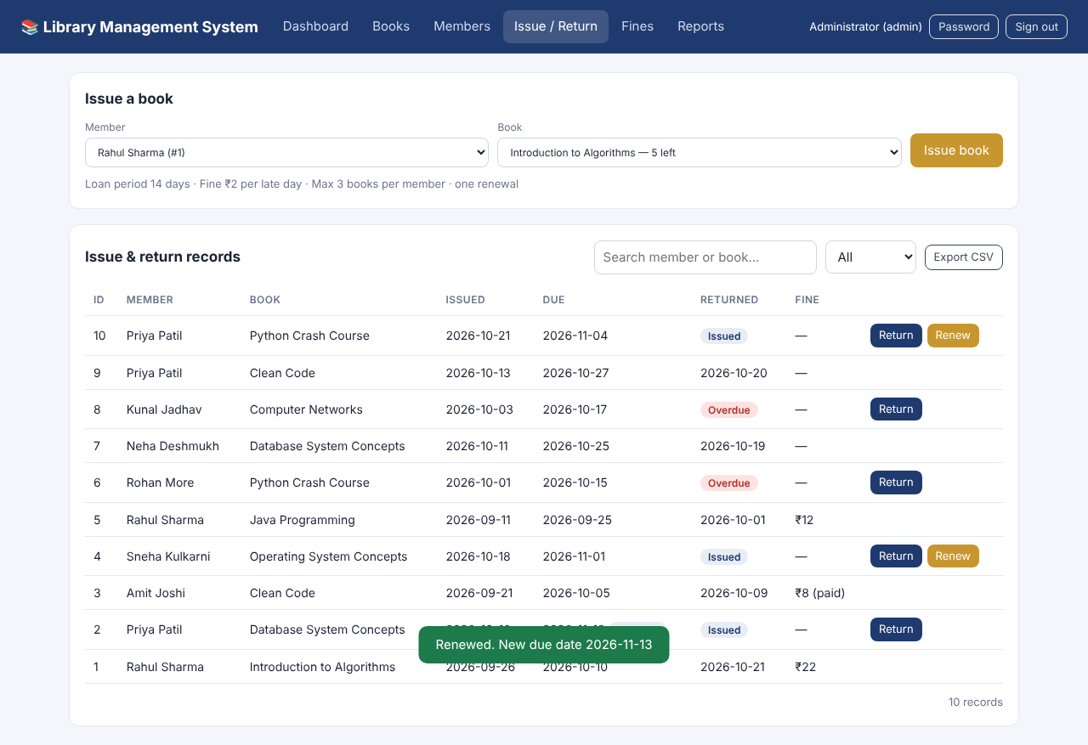
Fig. 19: Renewing a book
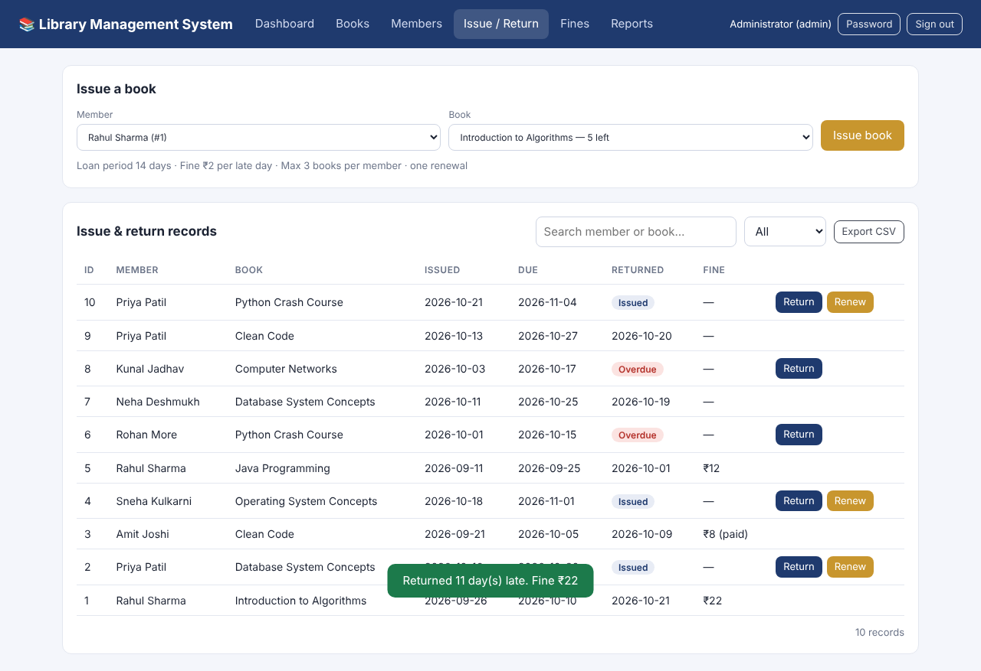
Fig. 20: Late return: fine of ₹22 created
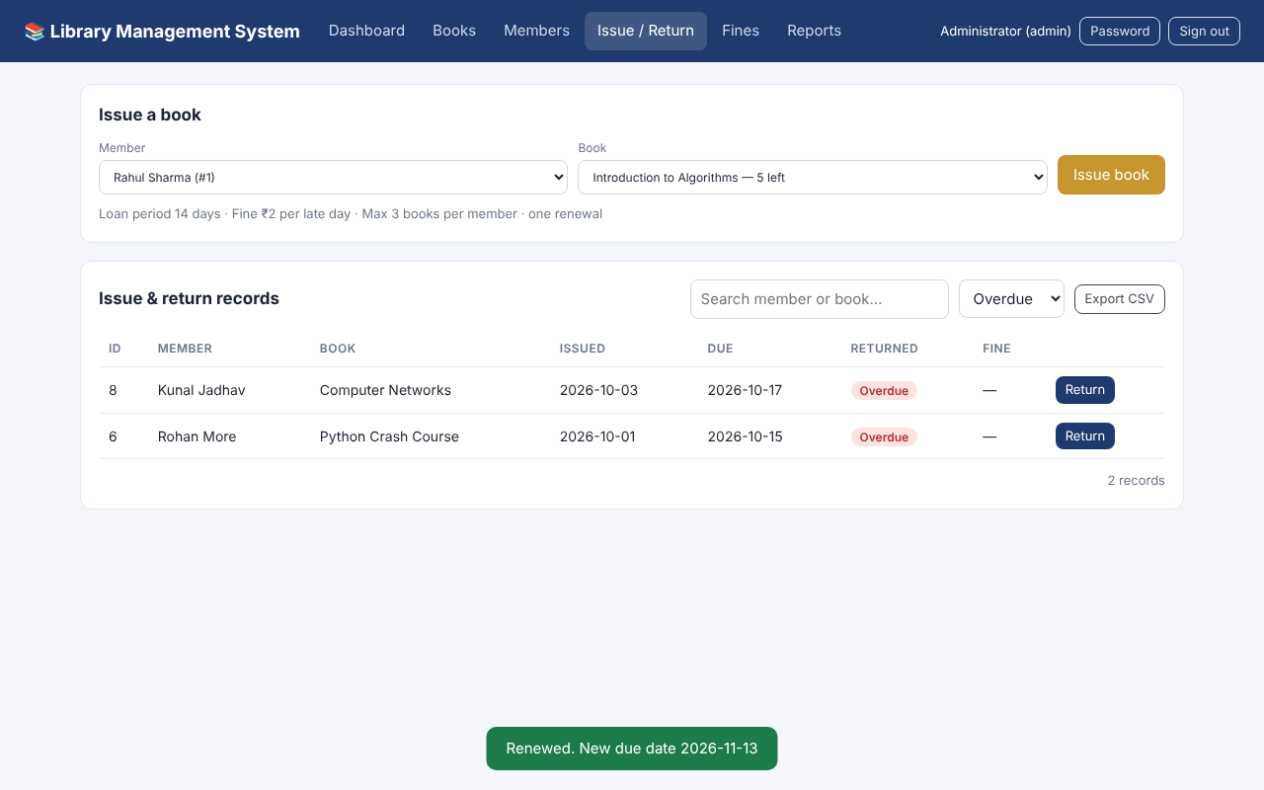
Fig. 21: Filter: overdue records only
Fines and reports. Fines can be marked as paid. The Reports screen shows overdue books, most borrowed books, books by category and (for the administrator) the activity log.
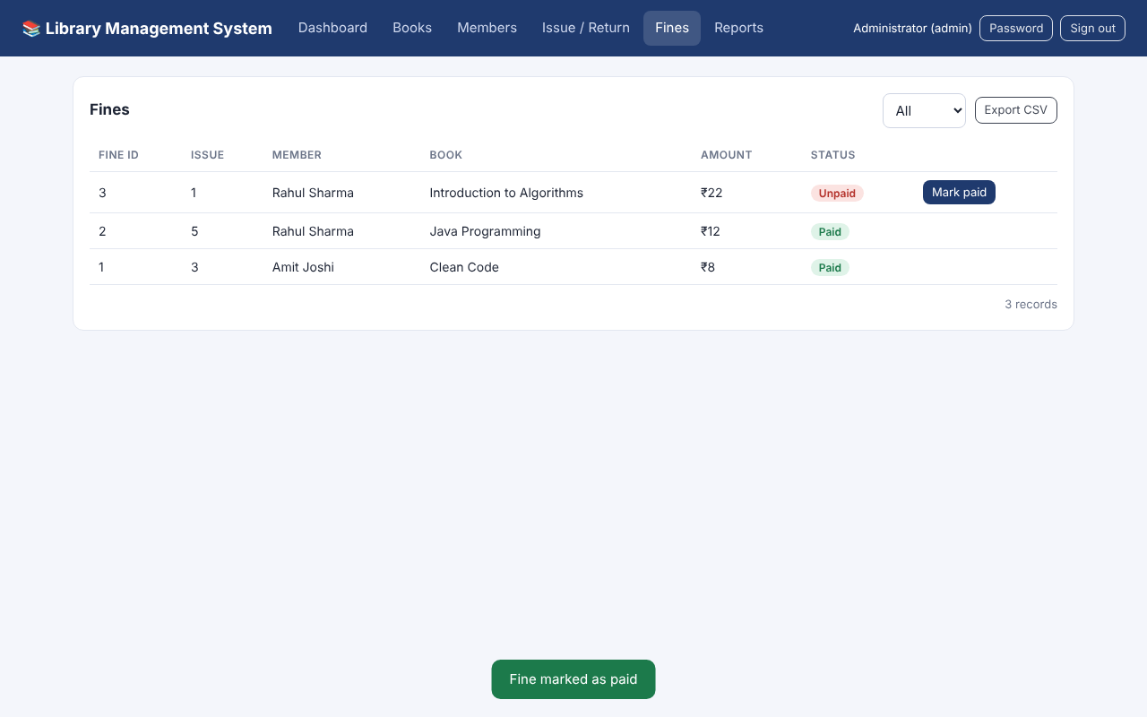
Fig. 22: Fines screen
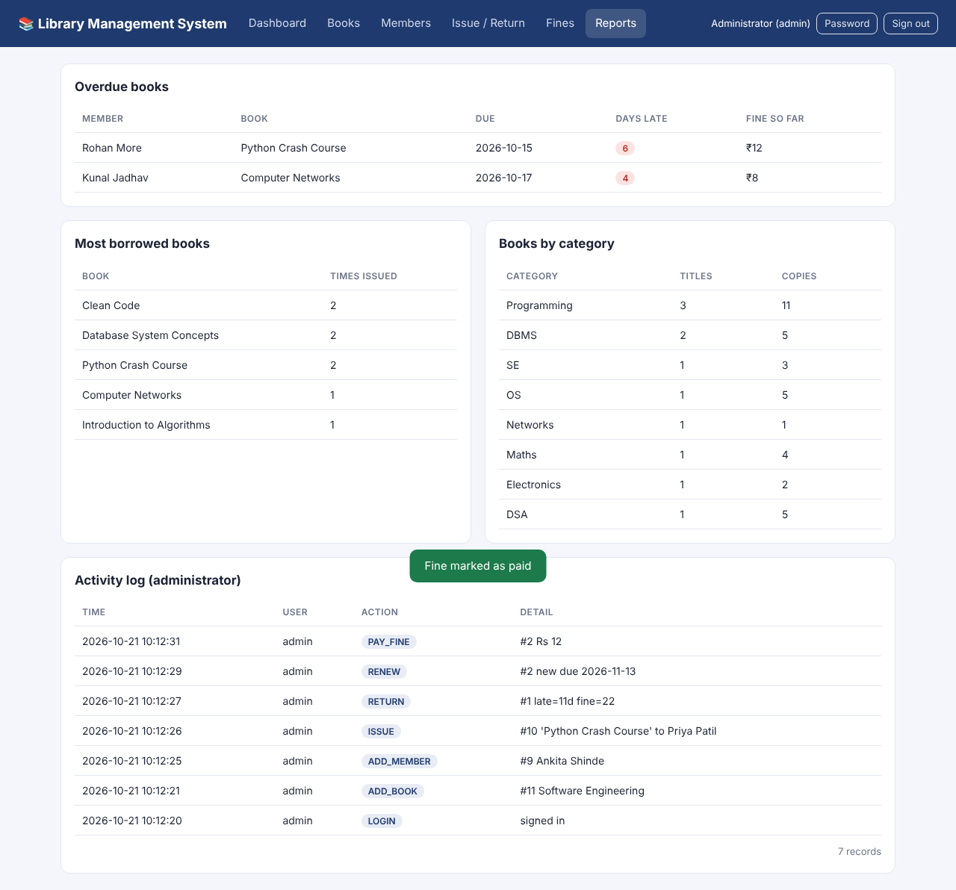
Fig. 23: Reports and activity log
4. Automated Test Results
The 27 tests cover login and roles, wrong passwords and lock-out, hashed passwords, forged requests, issue / return / renew rules, fine calculation, rollback of failed operations, validation, SQL-injection attempts, pagination, CSV export and the activity log. All tests passed.
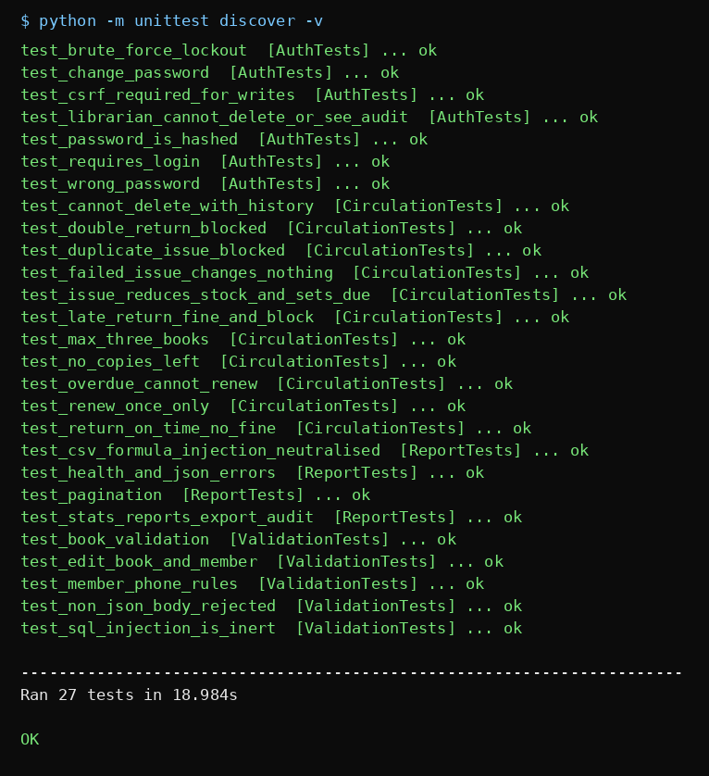
Fig. 24: Output of python -m unittest discover -v
Test Cases (selected)
Test | Expected result | Result
Issue a book | Due date = today + 14 days, copies reduced by 1 | Pass
Issue last copy twice | Second request rejected: no copies | Pass
Member with 3 books borrows again | Rejected: limit of 3 books | Pass
Member with unpaid fine borrows | Rejected: clear fine first | Pass
Late return | Fine = late days × ₹2, copy added back | Pass
Renew twice / renew overdue book | Rejected | Pass
Failed issue | Nothing changes in the database (rollback) | Pass
Request without login / without token | 401 / 403 error | Pass
5 wrong passwords | Account locked for the window | Pass
Librarian tries to delete or read log | 403 error | Pass
SQL text in a search box | Treated as plain text, no effect | Pass

Discussion
The results show that the database, the back end and the front end work together correctly. Rules are checked by the back end before any change, and the database constraints (keys, UNIQUE, CHECK) give a second level of protection. Because issue, return and renewal run as transactions, the stock count, the issue records and the fines always agree with each other.
Compared with the manual system, records are found instantly, fines are always calculated correctly, every action is recorded, and the librarian can see overdue books and unpaid fines at a glance. Daily backups, logging and Docker deployment make the system suitable for regular use.

- Conclusion and Future Scope
Conclusion
The Library Management System shows how DBMS concepts can be turned into a dependable application. Using MySQL with a Flask back end and a web front end, the system manages members, books, issues, returns, renewals and fines, while keys, constraints, transactions, roles and an activity log keep the data correct and secure.
The project covers relational design, SQL queries (JOIN, aggregate, view), a stored procedure and trigger, transactions, application–database connectivity, testing and deployment. It is organized as a GitHub-ready project with documentation, backups, Docker support and automated tests, so it can be used and extended after the course.

Future Scope
The system can be further enhanced by adding:
- Student login so members can search the catalogue and see their own loans.
- Online reservation of books that are currently issued.
- Email or SMS reminders before the due date.
- Barcode / QR-code scanning for faster issue and return.
- Fine payment through UPI or a payment gateway.
- Migrating the catalogue to MongoDB for flexible book metadata (NoSQL).
- A mobile application and more analytics (defaulters, department-wise usage).

- References
- MySQL Documentation, Oracle Corporation.
- MySQL Workbench Documentation.
- Flask Documentation, Pallets Projects.
- PyMySQL Documentation.
- OWASP Cheat Sheet Series (Password Storage, CSRF Prevention, SQL Injection Prevention).
- Docker and GitHub Actions Documentation.
- W3Schools, SQL Tutorial.
- GeeksforGeeks, DBMS and SQL Concepts.
- Database Management System course notes and classroom materials.

